CLOUDFRONT

CONCEPT OF CLOUDFRONT
- In the 1st scenario, California users get the response within 2 seconds because the web server is in the US, so the distance is less and they get low latency (fast response).
- But when Indian users send the request for the same content to US servers, they get the response in around 7 seconds because the server is far (not in India), so due to high latency the content is delayed.

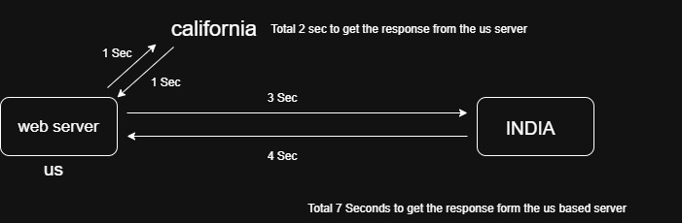

- In the 1st case, we get delayed response because of high latency, so to solve this we install servers in different locations like India / Canada / UK / Dubai, so users can connect to the nearest server and the latency issue is reduced.
- But for this setup, we also need to create database servers in all these locations to store data, and this data must be continuously synchronized with other database servers as well as with the origin server in the US.
- However, maintaining multiple servers and database synchronization increases the overall cost, just to reduce latency.

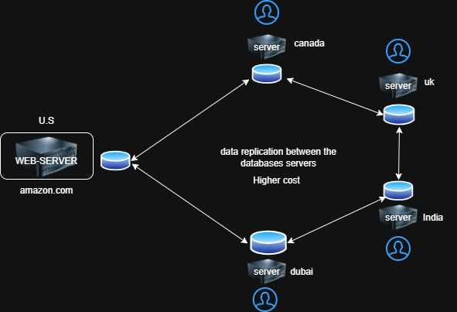
- That’s why we use a CDN service in AWS called CloudFront, which helps us achieve low latency without installing servers in every location.
- In CloudFront, we use multiple edge locations across different regions where the content is cached.
- When a user requests content for the first time, the request goes to the origin server (US). After that, the edge location stores (caches) the content.
Now, if another user requests the same content, the request does not go to the origin server — it is served directly from the nearest edge location, so the user gets fast response (low latency).

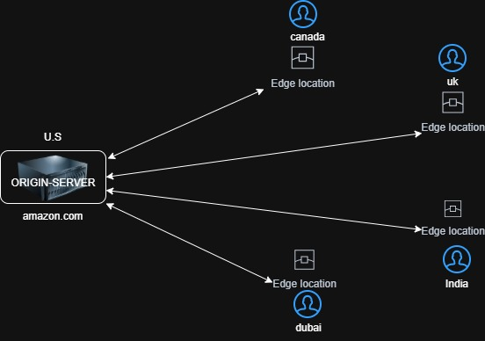

What is CloudFront
Amazon CloudFront is a webservice that gives businesses and web application developers an easy and cost-effective way to distribute content with low latency and high data transfer speed

What Is Latency
Time taken for data to travel from user → server → user

What Is Edge Location
- An edge location is nothing but a small server (cache location) placed in different regions that stores content temporarily (cached data).
- It helps to deliver content from the nearest location to the user, so users get very low latency and fast response immediately.
- At these time 400+ edge locations are present globally
- Also 13+ regional edge locations are present

CLOUDFRONT WITH S3 (STATIC WEBSITE HOSTING)

On S3 bucket
- create a s3 bucket (amazon-s3-bucket) and add css template in s3 bucket
- Then create a static web hosting and give them a public access

On CloudFront
- go to CloudFront
- create a distribution
- Distribution name -----> Cloudfront
- Distribution type -------> single website or app
- Origin type ---------------> Amazon s3
- S3 origin ------------------> <static website hosting url>
- Origin settings ----------> customize origin settings
- Protocol -------------> HTTP only
- Next ------> create

- Copy Distribution domain name & paste it on the web
{ dxsc0xi3hkw4.cloudfront.net }

Block the Country
- Click on the cloudfront distribution
- settings ----------> CloudFront geographic restrictions
- edit the countries
- Restriction type
- Block list ----> 1.uk
2.us
- save changes

Note:
- our static website hosting runs on the http protocol that’s why we use http in origin settings.
- In these we also block the countries so these countries users not accessing my website.
- But there is condition that only the users that uses the CloudFront url from uk us are blocked but when they use my static website hosting url directly they can access my website easily
- To fix these we use Origin Access Control (OAC) or OAI means Block direct S3 public access
- But if we want more control then that time we use WAF (web application firewall) that block the countries, ip addresses , malicious traffic

CLOUDFRONT WITH S3 -> BUCKET SHOULD BE PRIVATE

On S3 bucket
- Download a css template
- Create a s3 bucket (amazon-s3-bucket) which is private
- Add this css template in the s3 bucket
On CloudFront
- go to CloudFront
- create a distribution
- Distribution name -----> CloudFront
- Distribution type -------> single website or app
- Origin type ---------------> Amazon s3
- S3 origin ------------------> <S3 bucket only>
- Next ------> create
Add a policy in the s3-bucket

{
"Version": "2012-10-17",
"Statement": [
{
"Sid": "AllowCloudFrontServicePrincipal",
"Effect": "Allow",
"Principal": {
"Service": "cloudfront.amazonaws.com"
},
"Action": "s3:GetObject",
"Resource": "arn:aws:s3:::YOUR_BUCKET_NAME/*",
"Condition": {
"StringEquals": {
"AWS:SourceArn": "arn:aws:cloudfront::ACCOUNT_ID:distribution/DISTRIBUTION_ID"
}
}
}
]
}

Note:
- bucket_name:
- account_id:
- distribution_id of cloudfront:

Copy the CloudFront distribution name & paste it on the web
- DNS-Name/index.html

